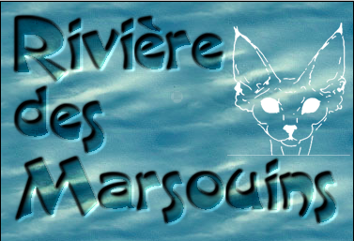
Chatterie de la Rivière des Marsouins
Delphine Behmann
chatteriedelarivieredesmarsouins@ymail.com
http://www.chatterierivieredesmarsouins.com

I’ve been a French breeder since 2007 and have been working as a vet since 1992.
My first cats, when I was a student, were 2 Persians. They lived during 20 years, and I decided I wouldn’t have another cat because I was tired of the grooming of Persians!

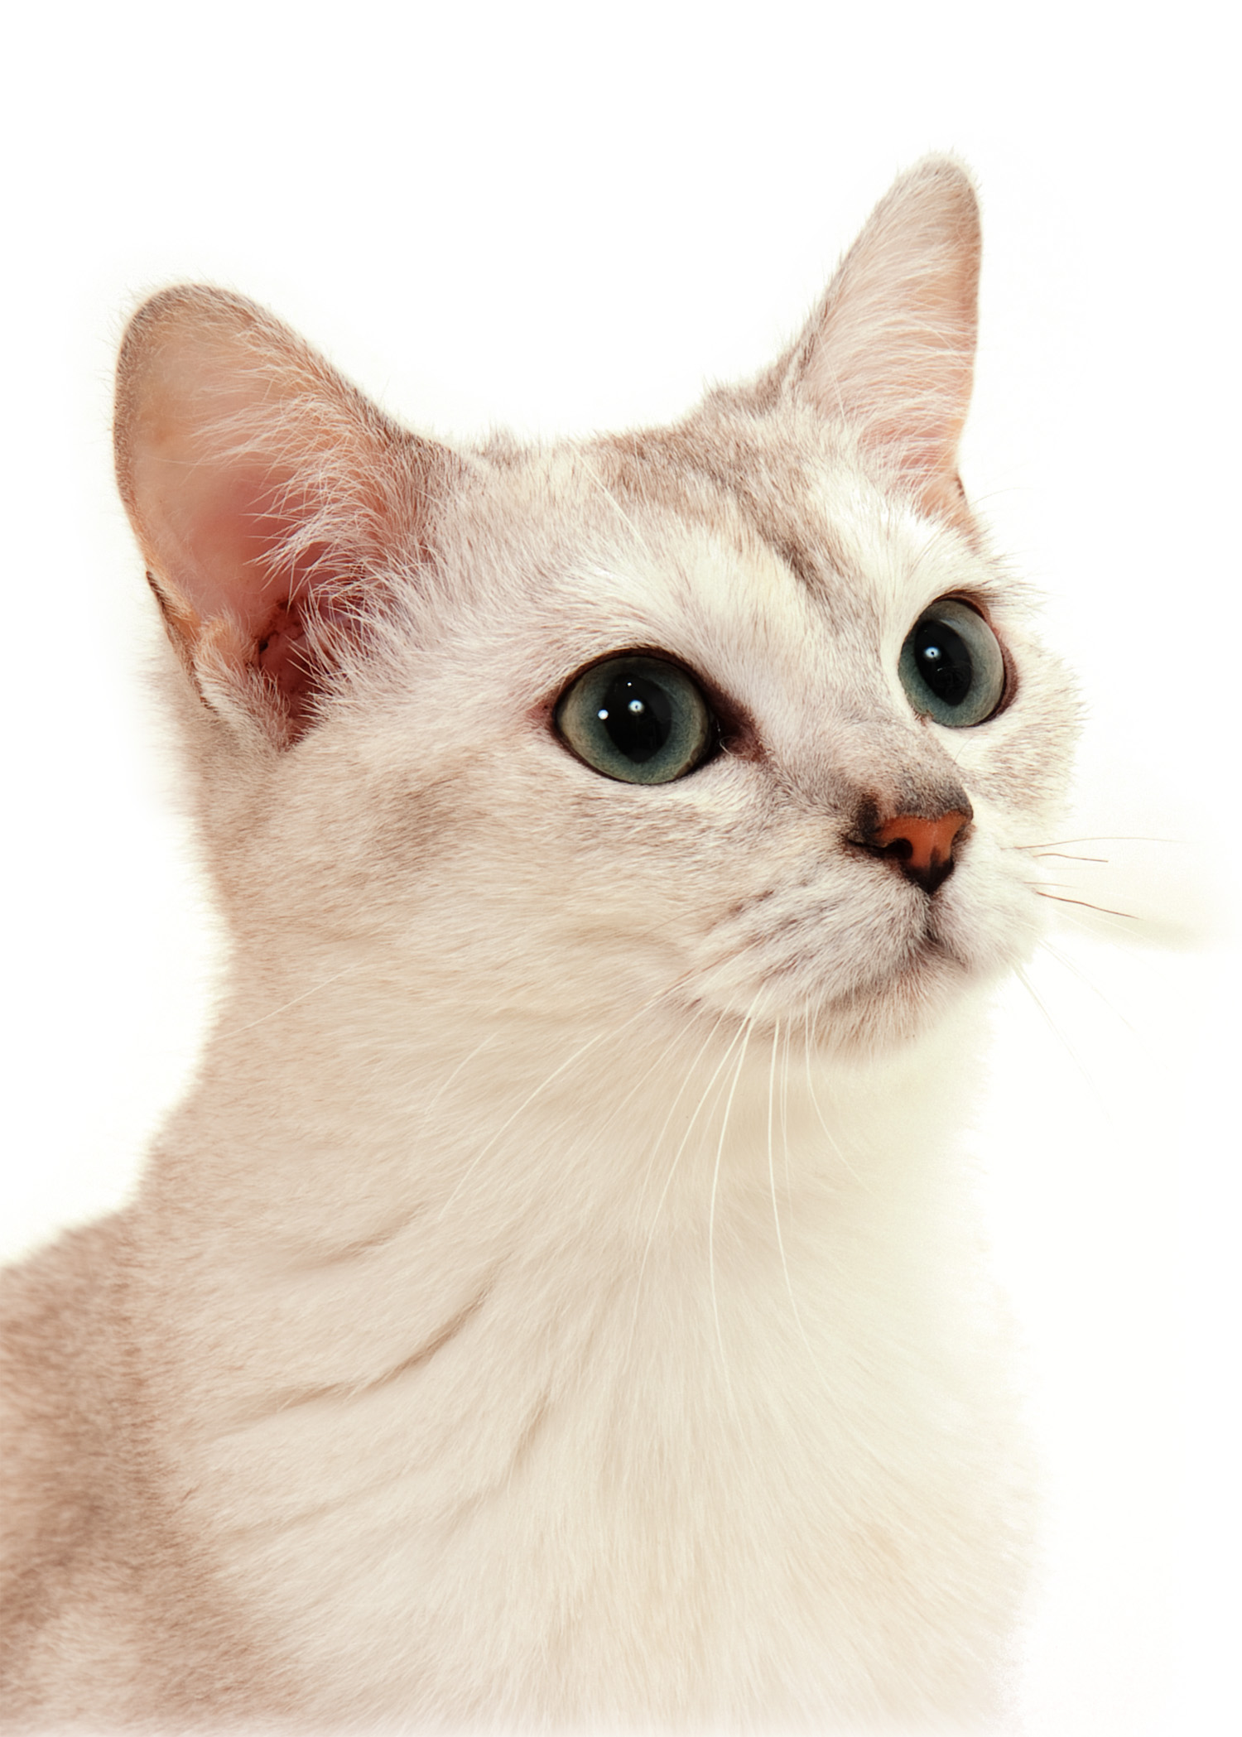
But soon, I missed their company and decided to have short haired cats. I began with Chartreux. It happened to be a mistake because if I love their external aspect, their temper was not suitable for me. Then, after longer information about the tempers, I choosed the Burmillas and added Devon Rexes after I got interested in the color genetics. I saw a gorgeous blue mink Devon girl on internet and wanted to be able to breed such a wonderful color. Therefore I bothered many breeders to do the DNA tests for me before I decided to buy my 2 first Devons.

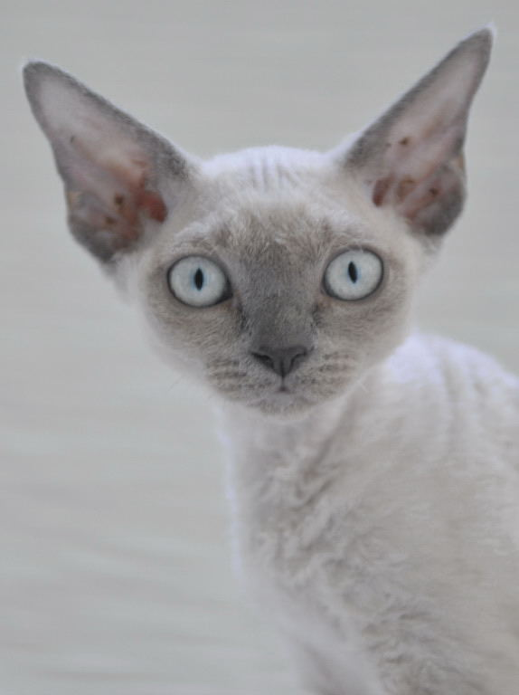
I finally found the ideal pair with Caty Curtil, Chatterie du Caramy, and welcomed home Don Quichotte, seal point and white, dilution carrier and Dragonne, seal mink, dilution carrier.
Don Quichotte died in an accident (jumped over the window despite the net) while Dragonne was waiting for her first babies. Hopefully she gave me a blue mink girl which I named Eurêka. Eurêka and Dragonne are still my breeding girls.

Some times after, I added a new stud: Fandango Imagine That, red point and white, chocolate and dilution carrier, and then the quest for delicate colors continued… The aim was now to breed lilac mink babies, so I looked for chocolate and dilute carrier girls. Megarex Lyra (from USA), a very cute lilac tortie and white, sepia carrier, joined our household.
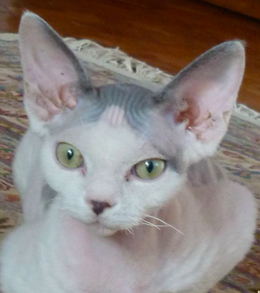
Then I realized that I had to choose between the Burmillas and the Devons, because I didn’t want to have too many cats (the girls live at home with us) and with my breeding program I will have to keep some babies to do an interesting job.
I began to keep Faust, a blue and white male for his very short muzzle.
So I decided to stop the Burmillas, even if I truly love this delightful breed!!
My friend, Elisabeth Morcel, Kreiz ar Mor cattery, a Maine Coon breeder, has been in love with the Devons for many years. She asked me for a girl. We shared views about my breeding program with the Devons and she decided to buy a boy I could mate my girls to. He’s a blue point, supposed a lilac carrier, because she shared my quest of producing lilac mink babies with a girl from Lyra.
She DNA tested him, and .. he’s not a chocolate but a cinnamon carrier!

That was an opportunity we couldn’t miss, so…. I looked for a cinnamon (at least carrier) girl, and Sonya of Katarine (from Russia), a gorgeous cinnamon tabby and white girl joined us.
Elisabeth’s stud mated all my girls, and I’ve got the joy to have Sonya’s first cinnamon babies!!
A cinnamon girl, a cinnamon tabby and white boy and 2 seal mink (carrier of cinnamon and dilution) 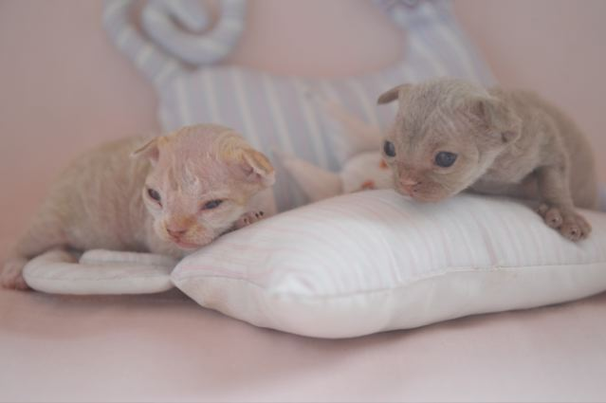

Dragonne gave me one blue point girl and one bluemink girl, Eurêka one blue point boy and a three blue mink boys, I will have to DNA test them to know which one is carrier, and I expect soon Lyra’s babies.
I will keep the nicest cinnamon carriers babies.

My previous lines may let think that I’m only interested in the Devon colors but of course that’s not the only challenge I have got with this breed. I’ve chosen to first get the gene pool that will give me the colors I want, without compromising the type. Now that I’ve got all the needed colors, I intend to work to improve the type. That’s the reason why I will keep many of Elisabeth’s studs’ babies .
Health issues are also my concern: all my breeding cats are yearly scanned for HCM, and blood group tested (of course I’ve got B females and A studs ..).

